Qualcomm Inc.

Functional Specification

ITG 264751

Enable Partial Receipt Capability - Partial Receipt Setup/Reference and 4B2 validations

Author : Ken Hatfield

: Rick Zuelke

Creation Date : November 8, 2010

Last Updated : February 22, 2011

Version : 1.2

## Document Control

**Change Record**

| Date | Author | Version | Change Reference |
| --- | --- | --- | --- |
|  |  |  |  |
| 8-Nov-10 | Ken Hatfield | 1.0 | Initial Draft |
| 18-Jan-11 | Rick Zuelke | 1.1 | Incorporate changes based on ITG 246370 - 3B2 / 4B2 Workflow replacement |
| 22-Feb-11 | Rick Zuelke | 1.2 | Incorporate 4B2 Validation |

**Reviewers**

| Name | Position |
| --- | --- |
|  |  |
| Ken Hatfield | Systems Analyst, Sr. Staff |
| Rick Zuelke | Systems Analyst, Staff |
| Marie Rousseau | Systems Analyst, Staff |
| Jon Morrissey | Business Process Analyst |
| Krishna Mendu | Programmer Analyst, Sr Staff |
| Daniel Velasco | Business Process Analyst, Sr. |
| Patti Lane | Systems Analyst, Staff |
| Hrishikesh Unni | Systems Analyst, Sr. |
| Steven Wilson | Sr. Manager, IT |

**Distribution**

| Copy No. | Name | Location |
| --- | --- | --- |
|  |  |  |
|  |  |  |
|  |  |  |
|  |  |  |

Contents

Document Control ii

Problem Statement 4

Terms 4

Reference 4

Functional Overview 5

Basic Business Need 6

Data Validation Processing 9

Open and Closed Issues 10

Open Issues 10

Closed Issues 10

## Problem Statement

Current shipment volumes combined with higher than normal constrained items have increased the need to perform ‘same day turn-arounds’ at the warehouses. This means the warehouse has need to receive enough inventory to support current days shipments (demand), even when the receipt performed is only part of an inbound shipment (ASN); then complete the receipt as time permits or additional inventory is required.

## Terms

* ASN – Advance Shipment Notice – an electronic message sent between trading partners from the party shipping inventory to the party (warehouse) receiving the shipment.
* TAP – short name in Oracle WMS for the inventory organization created in Singapore.
* 3B2/4B2 Maintenance Form – a custom form created in Oracle to allow users to query 3B2 and 4B2 message information. When errors exist in the transaction portion of the message flow a user with appropriate system authority can modify specific data elements and restart the transaction process.
* BPEL – Business Process Execution Language – An Oracle tool used to perform background system processes.
* Loopback Tool – a custom tool created by QCT/IT. This tool was originally created to support testing when trading partners were not available. The tool uses the data elements in an outbound message to create an inbound message to be transacted. A separate loopback took exists for the 3B2/4B2 receiving process than for the 3B12/3B13 shipping process.
* Partial Receipt – the ability to perform receipts against a single ASN in parts of the full quantity until the full quantity on the ASN has been received. The process must support two or more receipts against a single ASN; as well as allow the user to receive the ASN as a single, full quantity receipt.
* FLM - Fixed Lot Multiplier. Determines the quantity of chips in the Inner LPN or Pizza box. Ordered quantities must be a multiple of this number.

## Reference

ITG 146060 Receiving Lot Consolidation

ITG 184681 Receiving Buffer Overflow

ITG 246370 Replace 3B2 / 4B2 Workflow

ITG 264751 Modify 4B2 processing - Enable receipt processing to support multiple receipts against a single ASN

ITG 275717 Enhance the 3B2/4B2 maintenance form to support multiple receipts against a single ASN

ITG 279867 IFM – Buffer Overflow and Partial Receipt Modifications

ITG 279868 Drop Ship – Buffer Overflow and Partial Receipt Modifications

ITG 279869 DC Stock – Buffer Overflow and Partial Receipt Modifications

ITG 279871 SAT-to-SAT – Buffer Overflow Modifications

ITG 279874 Motorola Hub – Buffer Overflow Modifications

## Functional Overview

Warehousing for QCT business unit has grown dramatically within the past eleven years. In the late 1990’s QCT had one warehouse, resident in San Diego, and the system solution was PeopleSoft ERP. The receiving process allowed users to perform inventory receipts against purchase orders, and the receiving process could be performed in small shipments against a single purchase order line.

As QCT grew a second warehouse was created, residing in Singapore. A third-party logistics company was employed to run the warehouse and a system of messages was created to direct receipts and shipments, and to maintain inventory reconciliation between the third-party’s warehouse system (Exceed) and the ERP used by QCT. The warehouse in Singapore was created in PeopleSoft as an inventory organization and named QCTAP. All activity at DC Singapore was directed from QCT’s warehouse system in PeopleSoft. The ability to receive in portions (partial receive) of a physical shipment continued to be supported. The process of using Advance Shipment Notices (ASNs) was also being supported.

In 2002 QCT migrated their ERP system solution from PeopleSoft to one provided by Oracle Corporation. During the migration to Oracle Warehouse Management System (WMS) the ability to receive part of an advance shipment notification (ASN) was not ported over. At that time it was stated the Oracle Workflow process that controls the automated receiving solution would not support partial receipts. Each ASN received had to be processed in full with one Receipt Confirmation message.

In today’s business climate conditions exist that require some inbound shipments (part of a total inbound shipment) to be received into inventory and then reserved and shipped to a customer the same day. The problem being addressed in this ITG is one created due to increased volumes for same day handling (supply / demand imbalance).

The current receiving process deployed at DC Singapore contains a system restriction that for every 3B2 (ASN) message sent to Schenker a single 4B2 (receipt confirmation) message must be received and processed. This means that for every packslip (shipment) that arrives at the receiving dock in Singapore the receipt must be processed in one single transaction.

The business unit has requested the capability to perform partial receipts of each shipment, allowing them to receive only the inventory required to make urgent shipments; then follow up by receiving the remaining inventory on the ASN to put away for later shipments.

**Simply stated;** the business unit has required the receiving process support multiple receipts against a single ASN inbound to the warehouse.

## Basic Business Need

Through the years of global operation the business unit has created multiple receiving flows, each specific to a business need. The business has now required that each receiving process support partial receipts. Testing has been performed for each receiving process, the results of which can be found as attachments to this ITG.

The following outlines the business requirements:

1. Each receiving flow, with the following exceptions, shall support multiple receipts against a single ASN packslip.
   * The first exception to this requirement is the receipt of die inventory that has been shipped from a Fab to a SAT. In this case the business unit requirement continues to be a single receipt for the entire quantity on the ASN. All requirements stated in this document pertain to all receiving flows except the die receipt flow (Fab to SAT, or SAT to SAT).
   * The second exception is that receipts associated with the NC or RMA processes are not included in this enhancement set.
2. Enhancement shall support:
   * Flexmart FGI receipts
   * Turnkey FGI receipts
   * DC Stock FGI receipts
   * DC Unstock FGI receipts
   * Manual IFM receipts
3. Enhancement shall support receipts into all DC warehouse orgs setup in Oracle ERP. These organizations are defined in setup as ‘Distribution Centers’. Current examples of these warehouses are:
   * TAP
   * SAP
   * GTC
4. The receiving processes shall allow for one or many receipts against each ASN.
5. Each partial receipt shall support:
   * All, or any portion of the total quantity on the ASN
   * All, or any portion of the lots included on the ASN
   * Assumptions:
     + Exceed system has a restriction to only receive full box quantities based on pizza box quantity (also known as FLM or pan size).
     + If a user manually receives via loopback tool or Oracle, it is the user's responsibility to maintain receipts at box quantities.
     + If a non-FLM quantity is received for a lot, it can be pick released. This would cause quantities for lots which do not relate to whole pizza boxes. If this condition occurs, the delivery will be backordered and corrected before re-picking the Sales Order Line.
6. This enhancement shall use as much of the standard Oracle receiving processes as possible to preserve the receiving and procurement relationship.
7. Shorten delays which cause processing to wait for pre-determined amount of time before proceeding.
   * Current Functionality – to be corrected: When workflow finishes processing a 4B2 receipt message for a partial receipt of a packslip. There is a delay before the next message for the same packslip is picked up and processed. It takes approx. 7.5 minutes in the test environment for each 4B2 message to process for the same packslip. Testing was performed with small quantity and minimum number of lots (1 or 2 lots).
   * Processing shall be enhanced to reduce all wait states as much as possible to expedite the receipt process.
     + Related to ITG 246370 – 3B2 / 4B2 Workflow Replacement
8. This enhancement shall support not only receiving flow that processes messages through Tibco and BPEL, but must also include the 3B2/4B2 Loopback Tool to properly support testing and system contingency plans.
   * See ITG 275717 – 3B2 / 4B2 Maintenance Form changes
9. Error processing will provide reason for failure.
   * Example: Error message lists message IDs and PO, but does not report validation error.

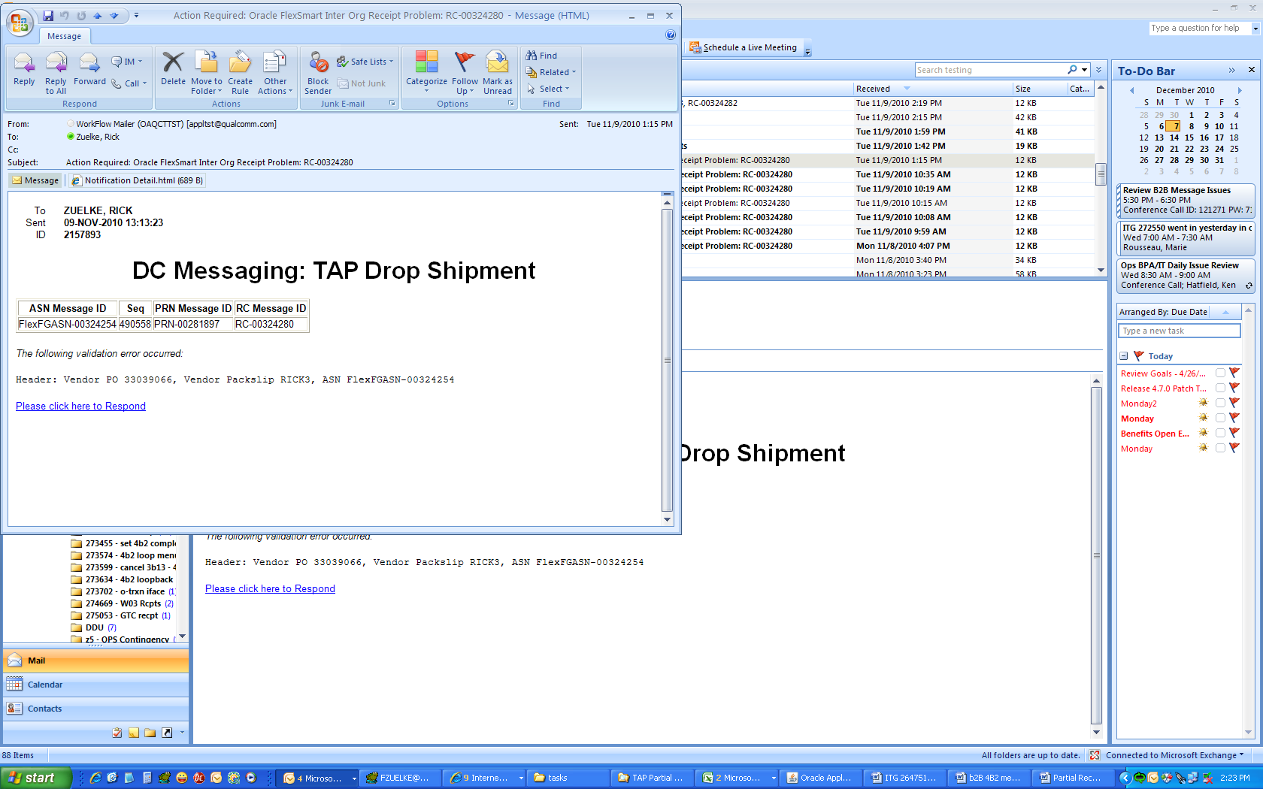

* + Because workflow is being replaced, error message generation will follow error processing model which is used in production today. Example:

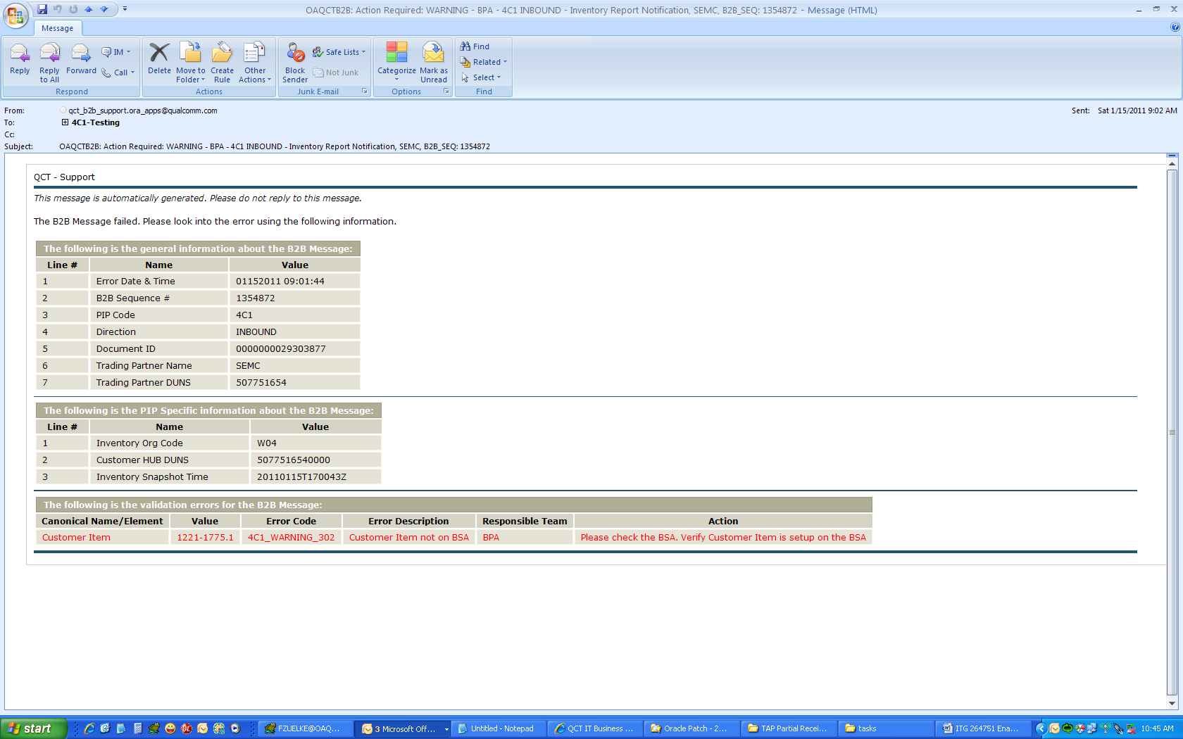

* + For 4B2 Validation Errors and Codes, see validation spreadsheet attached to this ITG.

1. For future consideration: If LPN processing is used during the receiving transaction, partial receipts of LPNs will not be allowed. Only complete LPNs will be received.
   * A single lot may exist in multiple LPNs. As stated above, a portion of a lot can be received. In this case, one or more complete LPNs would be received now, while other LPNs with the same Lot are received at a later time.
   * We do not currently store inventory LPN information for any Distribution Centers. The functionality is noted here as a place holder for discussion when inventory LPN information is enabled in the DCs.
2. Modifying enforcement of validation rules.
   * Receiving workflows contain mismatch between validation error message and the enforcement of the validation.
     + Example: Vendor ID error message is generated when workflow begins, but transactions are allowed to process until LPN transfer to FGI. This is when workflow prevents transaction from occurring.
     + This is a poorly placed enforcement of the validation rule. Receipt occurs into INBOUND/INBOUND even though vendor ID on 4B2 does not match vendor ID on 3B2.
     + With replacement of workflow, this must be corrected. If an error message is generated, the message will go to ERROR status and receipt will not occur for the affected inventory.
     + This change is made in conjunction with ITG 246370 – 3B2 / 4B2 Workflow Replacement.

## Data Validation Processing

The following functionality will be available to validate inbound 4B2 messages:

1. 4B2 Validation
   1. Triggered based on DC 4B2 in “NEW” status
      1. Will run validation for a Single 4B2
   2. Modeled after Huawei 4B2 Validation
   3. 2 run Modes: 1) Single 4B2 and 2) All
      1. Single 4B2:
         1. Only the 4B2 Message ID listed as parameter will process.
         2. Processing will occur if 4B2 Message is in the following statuses:
            1. NEW status
            2. ERROR status (include all ERROR statuses)
      2. ALL:
         1. No 4B2 Message ID is listed as parameter.
         2. ALL 4B2s will process which are in the following statuses:
            1. NEW status
            2. ERROR status (include all ERROR statuses)
   4. Concurrent Request Definitions
      1. Responsibility:
         1. QCT OPS SUPERUSER
      2. Request Group / Security:
         1. All WMS Reports
      3. Menu Step:
         1. Not needed in Menu Tree
         2. Available in View / Requests pull down menu
      4. Request Name:
         1. CHP DC 4B2 Validation
      5. Parameters:
         1. Value set (LOV)
            1. LOV: 4B2 messages with status (NEW, ERROR)( (include all ERROR statuses)
            2. “ALL” value entry allowed

Default to “ALL”

* + - * 1. LOV will contain the following values:

4B2 Message ID

* + - 1. Sort Order
         1. 4B2 message ID, descending
    1. Concurrent Request Functionality:
       1. When run, concurrent request will validate 4B2 message(s).
          1. Valid messages will be marked with VALID status at Header, Line and Detail.

No e-mail output is generated for VALID messages.

* + - * 1. Invalid messages will be marked with ERROR status at Header, Line and Detail.

Invalid messages will have alert e-mail message sent. See attached Validation Spreadsheet for specific information.

* + 1. See Validation Spreadsheet attached to this ITG for specific information regarding:
       1. Output Format
       2. E-mail distribution lists
       3. Error definition and text

Attached Spreadsheet(s) list all the data validations required before populating the Receiving open interface tables. Validations are categorized in the categories as listed below:

1. M-IFM/Turnkey Receipt Validation: Lists all the validations required for any PO Receipt being performed in the system. Drop Ship Receipt is performed for any Turnkey/Manual IFM receipt.
2. DC Stock Validations: Lists all the validations required for any Internal Receipt being performed in the system. Internal receipt is performed for any DC Stock Receipt.
3. Mot Hub replenishment Validations: Lists all the validations required for any Motorola hub replenishment receipt being performed in the system.
4. IFM FG Receipt Validations: Lists all the validations required for any IFM FG receipt being performed in the system.
5. SAT-TO-SAT Validations: Lists all the validations required for any SAT TO SAT material movement receipt being performed in the system.

## Open and Closed Issues

### Open Issues

### Closed Issues